**GUIDE TO ACCESSING DATACAMP**

**Step 1:** Click the link “ <https://www.datacamp.com/groups/fpt-software-3b3f6ff2-31b5-4371-a8c0-2c710f8d2612/sso/saml/login?path=/home>” and “**Next**”

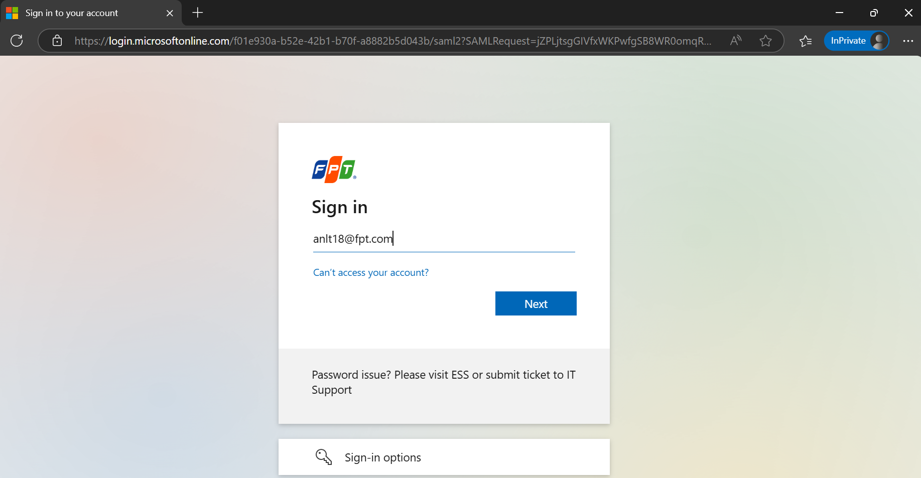

**Step 2:** Go to Home page



